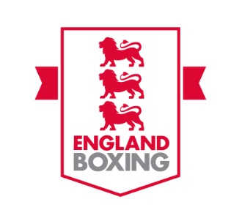
Merchandise order form
Name
Telephone number
Address

If more than one, please state the number of badges of each type you would like to order.  Pin badge (£3) ☐  Number (if more than 1):  Coach badge (£3) ☐  Number (if more than 1):  Officials badge (£3) ☐  Number (if more than 1):  Coach/Official badge (£3) ☐  Number (if more than 1):  Assistant Coach badge (£3) ☐  Number (if more than 1):  All prices include postage and packaging. | Payment details:  Date of payment:  Name used for reference:

Please return this form to enquiries@englandboxing.org and make payment into our bank account:
Sort code - 40-35-29
Account number – 41482777
Please use your full name as reference.

