R&J Experiential Learning Logbook

As part of your ongoing development and progression you are required to keep an updated log of your R&J experiences and duties. Experience and time to build your knowledge and exposure is essential.
England Boxing recognise the potential of mentoring to support and stretch individuals to achieve their own potential. As an emerging official who is completing an education course it is important that you seek feedback when possible from credible and experienced officials (Grade B, A, Supervisors and other R&J Developers from different regions).
The ability to critically reflect upon your experiences is also essential.
The table below outlines the minimum requirements from an experiential point of view to complete the course for Grade C and B for Judge & Time Keeper and Referee.

R&J Grade C  (Minimum Experiences to Complete the Course) | R&J Grade B  (Minimum Experiences to Complete the Course)
The below is the minimum you need to register and complete before certification and final ‘sign off’ from the R&J Developer:  Judge  - Minimum of 10 Bouts  - Different Ages?  Timekeeper  - Minimum of ___ Bouts  Referee  - Minimum of 10 Bouts | The below is the minimum you need to register and complete before certification and final ‘sign off’ from the R&J Developer:  Judge  - Minimum of 10 Bouts  - Different Ages?  Timekeeper  - Minimum of ___ Bouts  Referee  - Minimum of 10 Bouts

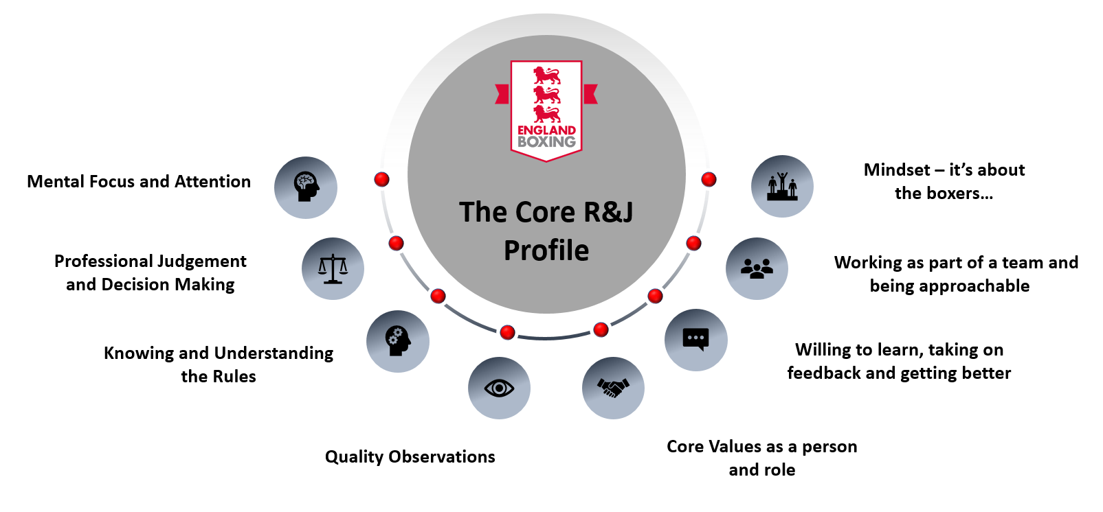
As a reference point please use the R&J Profile to help you reflect on what aspects you need to work on and also how you performed.

The GROW model is also a useful process;

G Goal: What is your goal?

R Reality: How did you perform?

O Options: What can I do now?

W Way forward: Decide on the next steps.

Reflective questions based on your experience:
- How did you maintain your focus and attention during the competition, did this vary during the competition?
- What did you learn about your observations (what, who and where you looking)?
- How did you apply your knowledge and understanding of the rules?
- How were you making decisions during the competition, what key decisions did you make?
- How did you uphold the core values of being a R&J and also your own personal values?
- What feedback did you receive, was is clear with positive intent and constructive?
- How did you work as part of the team, what was the level of team work and communication like?
The R&J Log Book
Once you have completed the R&J Log Book you need to send a copy to your R&J Developer who delivered your course (photo copy via a phone for example). A copy of this will be stored with England Boxing and your region.
It is essential that you also keep a copy for future reference if you wish to progress. At this stage England Boxing would encourage you maintain this level of reflection for your own learning.
Where and when did the competition take place? | Who was the lead R&J at the competition? | What was your role during the competition? (R, J, T) | How did you perform?  What went well?  What did you gain from this experience? | Signed and Date
E.g. Derby City ABC Youth Male (Aug  12th  2021) | Lead Official – Dave Smith | Completed  3 x Referee  3 x Judge  2 x Tkpr Roles | Overall really well. Need to focus on my observations and balance on what I am seeing. At times got distracted with the sound. Paper all good and the feel part of the team was positive. Received some positive feedback. Looking at my decisions they were on the right track. Need to explore the following rules again ________. Good start. Time keeper role went really well. The following things happened in the competition_____________________. | Aug 12th  2021
1.
2.
3.
4.
5.

6.

7.

8.

9.
10.

