R&J Developer / Mentor Observation and Assessment Competency Check and Final Sign-off.

Following attendance at the Officials Learning Centre each candidate will be required to develop their own personal action plan. The next step is for candidates to start their journey of ‘in the field’ delivery and build their competency via actual delivery. Candidates will have a range of options to practice and the role of the mentor will be essential within the process. The final stage of the sign-off process is a R&J Developer /Mentor observation and assessment of learning. The below form needs to be used to capture observations and signing off competency. The framework for sign off will provide a guide however it is professional judgement of the R&J Developer / Mentor which will be critical. Having another point of view from another Developer / Mentor is an option and if required multiple observations maybe required to complete the sign off process.

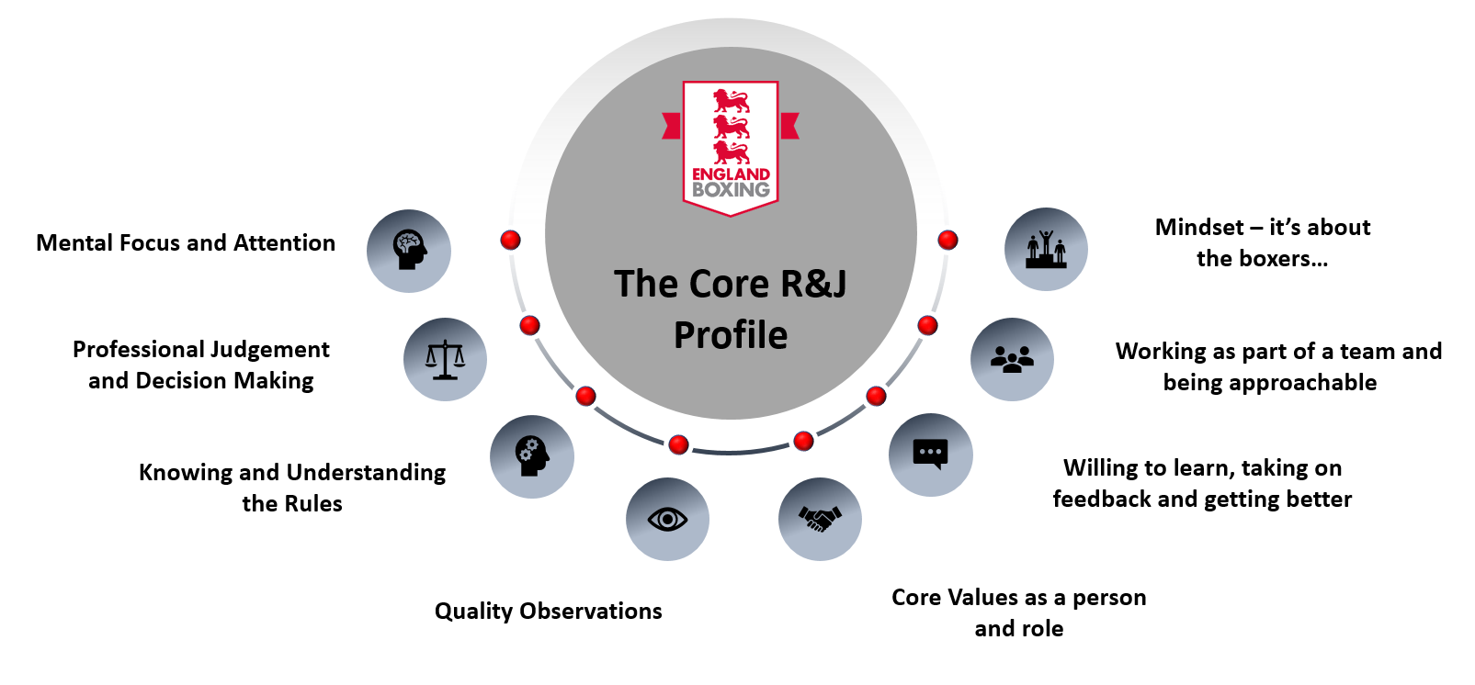

Core Model Element | Specific Elements | Competent (Y / NYC) | Comments | Initial
Mental Focus and Attention | Did the candidate demonstrate the right level of mental focus and attention during the event / competition?
Professional Judgement and Decision Making | Did the candidate demonstrate sound judgement and effective decision making specific to their role?
Knowing and Understanding the Rules | Based on your observations and interactions does the candidate have a suitable level of knowledge and the application via their understanding to delivery their role?
Quality Observations | Did the candidate make quality observations (right place, noticing what matters)
Core Values | Based on the candidates behaviours, actions and interactions do they have suitable core values to be a England Boxing Judge and or Referee
Learning Mindset | Based on your observations, feedback from others and interactions does the candidate have a growth mindset to learn and reach their potential?
Working within a Team | Based on your observations, feedback from others does the candidate work effectively within a team?
Mindset  It’s about the Boxer(s) | Based on your own professional judgement does the candidate fundamentally have a ‘its about the boxer(s)’mindset (safety, fair decisions)

Overall Feedback for candidate:

Agreement
R&J Developer |  | Sign |  | Date
Candidate |  | Sign |  | Date

The main copy of this form will be given to the candidate however a digital image photocopy is required to be taken and shared with England Boxing for future reference.

