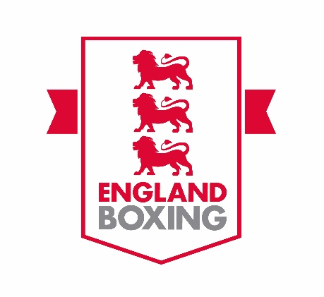
ENGLAND BOXING LEVEL 2 PROGRESSION
COACH ONLINE WORKSHOPS
Introduction
As part of the coaching pathway, England Boxing has designed and is introducing three new online coaching workshops for current England Boxing Level 2 Coaches. With the impact of COVID, online delivery is the only current option and the workshops have been designed based around these constraints.
Details of the three workshops are outlined below.

Club Coach Leader Workshop
(Six-hour workshop via Microsoft Teams), maximum 20 participants per workshop. The online workshop is split into two sessions (Session one = three hours. Two week gap. Session two = three hours).
Content to include:
- Maximising the boxer experience within your club
- Welfare of boxers and providing a safe and inclusive coaching environment
- The role of the lead coach within the club
- Coaching practice (creative sessions), Plan – Do – Review
- Working and leading a coaching team
- Evaluating and reviewing the annual coaching programme
- Legislation and guidance.

Competition Lead Coach Workshop
(Six-hour workshop via Microsoft Teams), maximum 20 participants per workshop. The online workshop is split into two sessions (Session one = three hours. Two week gap. Session two = three hours).
Content to include:
- What does effective planning look like and the areas we need to consider as a lead competition coach?
- Knowing and understanding the rules (our ability to understand what the Judges are looking for)
- Role of coaching practice (specific focus on technical, condition and open sparring)
- Padding with purpose, video analysis and reading the bout
- Coaching from the corner (the ability to land your message, reinforce, reconfirm and recommend).

Integration and Application of Sport Science Workshop
(Six-hour workshop via Microsoft Teams), maximum 20 participants per workshop. The online workshop is split into two sessions (Session one = three hours. Two week gap. Session two = three hours).
Content to include:
- Explore current and relevant topics that focus on sport science and its connection to coaching
- Specific focus towards Strength & Conditioning, Physical training & Planning, Sports psychology and nutrition
- Based on ‘action learning’ which normally starts with an overall theme or topic via a question and the group discuss and explores.

To secure a place
Go to www.englandboxing.org/courses/level-2-coaching-courses/ where dates of courses are displayed at the bottom of the page. You can also book by clicking on the red ‘book a course here’ link.
Please note that you must be an England Boxing Level 2-qualified coach to take part in one of these workshops.

