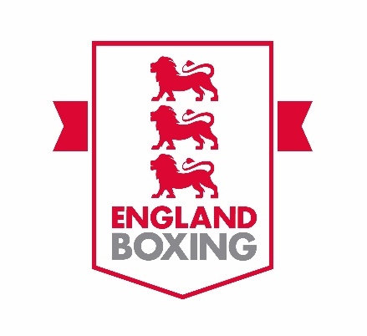
VOLUNTARY ROLE – ENGLAND BOXING
COMMUNICATIONS SUB-COMMITTEE

Introduction

England Boxing is the National Governing Body for the one of the oldest sports in the world, one which has featured in the modern Olympic Games since 1904.

With its own heritage going back to the 1880s, including the first national competition in 1881, the organisation is responsible for promoting and developing the sport at all levels, from grass roots through to the England talent pathway and, in turn, passing prospective medallists on to GB Boxing. The organisation is a member of AIBA and EUBC, the World and European governing bodies respectively.

Clearly stated ambitions in England Boxing’s strategy includes providing clear communication to the membership, increasing awareness of the positive aspects of the sport and helping contribute to revenue generation.

Falling under this remit are a wide range of work areas including, among other things, marketing and campaigns, the website, live streaming, media relations, brand management, social media and newsletters production and distribution.

In order to assist the communications arm of its operation run effectively, England Boxing is seeking to recruit two volunteers who have the appropriate skills, knowledge and experience to join the Communications Sub-committee and help drive delivery.

The Sub-committee reports directly into the England Boxing Board and is chaired by England Boxing Director, Mehul Kapadia.

It is expected that the successful individual will have an in-depth knowledge of at least one aspect of Communications, ideally in branding, social media or commercial operations, and applicants from both the England Boxing Membership and the wider community are encouraged to apply. Applicants do not necessarily have to have a vast knowledge of boxing.

Subcommittee remit includes

- To increase social media engagement across all platforms, particularly Instagram, Facebook and Twitter to reflect England Boxing's growing number of clubs and to enable direct communication with the membership.
- To align all England Boxing branding across all online and offline media and publications, including letters, handbooks, email signatures, banners, clothing, website, social media etc.
- To provide appropriate input into ensuring that the competitions and events operate in such a way that they are commercially attractive, well attended, branded, marketed and presented to a high standard and to a level commensurate with other national championships and similar events.
- To secure greater engagement with broadcast, online and written media, earning a greater earned media presence.
- To develop the organisation’s video output and make it more dynamic in a world where people read less and watch more, together with improving the quality and engagement of regular live streaming services.
- To keep staff, members and external stakeholders of England Boxing up-to-date with what is happening in the amateur boxing world, ensuring that campaigns reach intended recipients in good time, promote the good work England Boxing is doing and, where relevant, signpost people to take action.
Sub-committee members are in place for a maximum of two terms, (a term constitutes four years), but shorter terms of commitment may be considered.

Successful applicants will be expected to commit to attending four meetings a year, which are frequently conducted via Zoom.

Person Specification
The Sub-committee has expertise in a number of Communications-related fields, but, as mention in the introduction, is looking to strengthen in other areas. Applicants would be particularly welcomed with specific experience in the following:

- Organisation-wide and event branding, which ensures consistency across the business, and partner activations.
- Experience in commercial and sponsorship activity, including the marketing.
- Knowledge of social media platforms, existing and emerging, and how best to utilise them.

Benefits

- Valuable exposure to the sport of boxing and its operations at a national level, both from a competitive and community perspective.
- The opportunity to attend seven national events a year, including the England Boxing National Amateur Championships Finals Day, the organisation’s flagship event, which has been won in the past by household names such as Anthony Joshua, Tyson Fury, Nicola Adams, Carl Froch, Frank Bruno, Natasha Jonas, David Haye, Savannah Marshall and Charley Davison, and has been running since 1881.
- Although this is a voluntary position, reasonable out-of-pocket expenses will be reimbursed for travel to meetings, etc.

To apply

Send a CV (including contact details) and covering letter, detailing the relevant skills, knowledge and experience you have in relation to the Sub-committee subject matters to: hrapplications@englandboxing.org

Closing date for applications – Monday 31st August 2020.

